**SUNHANS eSunRC 4000mW 5.8Ghz 36dBm WiFi Signal Booster**

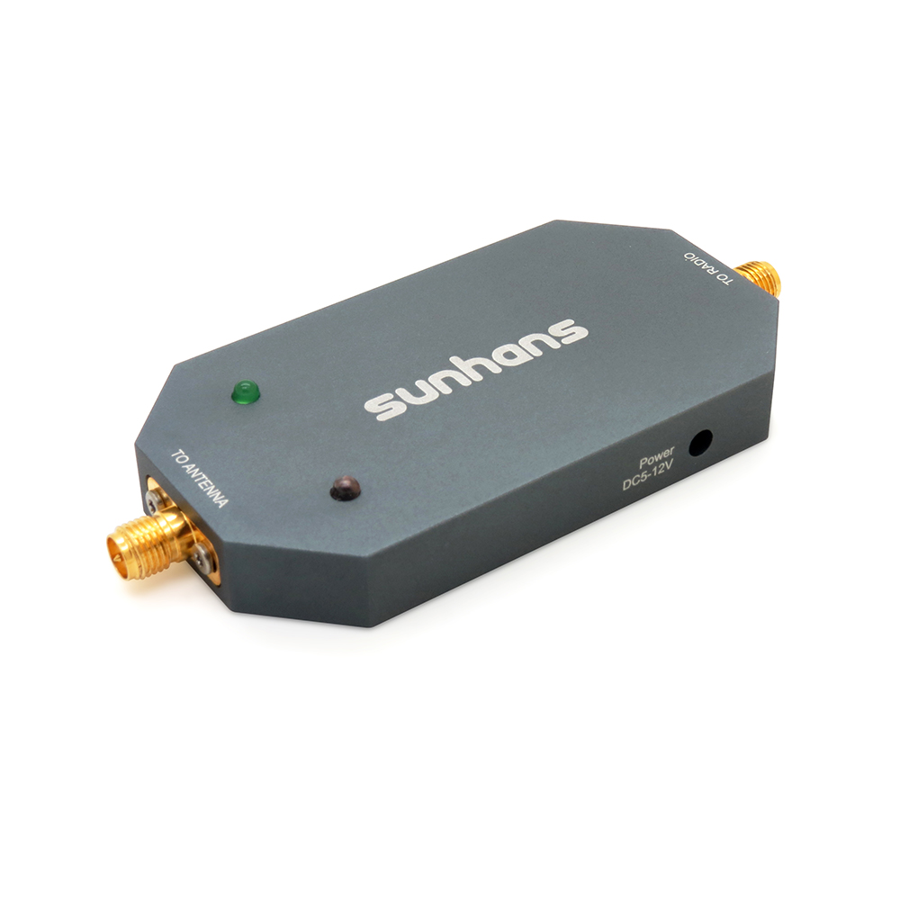

**SKU: 0305SH200789**

**Model:** **SHPro58GTX4W**

**P/N: Pro58GTX4W019**

**Barcode:**

**Features:**

5.8GHz, Max. 4000mW output power;

Aluminum-alloy case by CNC, anti-interference;

Full kit, easy to install;

Designed for Drones, UAV, RC equipment....

**Technical Specifications**

Booster model: SHPro58GTX4W

Operating range : 5000~5875MHz

Channel width: 20Mhz&40Mhz&80Mhz

Supported standards: IEEE 802.11a/n/ac

Operation mode: Bi-directional, half-duplex, time division duplex

Connector type: To radio SMA female (hole inside).

To antenna RP-SMA female (pin inside)

Output power: 4000mW (36dBm)

Input power: 0 ~ 20dBm

Transmit gain: 17 ~ 20dB

Noise figure: ≤3.5dB typical

Frequency response: ±1dB over operating range

Power adapter: 5-16V/2A DC

Material: Cast aluminum

LED light: Power status LED and activity status LED

Booster weight: 59g  
Booster size: 9.2*4.1*1cm

**Package Weight:**

**Package Size: 12 x 11 x 6.5cm**

**Package contents**

* SHPro58GTX4W eSunRc WiFi booster
* RG141 20cm cable SMA male to RP-SMA male
* DC 2.5” to 12V 5.5” adapter
* DC 2.5” to USB adapter
* DC 2.5” to JST adapter
* Mounting Velcro
* User Manual